This document describes about the solution for the given Techolution assignment

Solution for finding Maximum Satisfactory Level for the items in a given time

I have used <http://start.spring.io/> to create a Springboot project and have given artifact and group name.

<groupId>com.gopi.restaurant</groupId>

<artifactId>techolution</artifactId>

**Note** : I have selected the type as **Maven**. After giving all the inputs click generate project button , it will download a maven project with the group name and artifact name given which I imported in my eclipse and started implementing the problem by writing test cases first and copied the green test cases code to my controller and so on.

My Git repo url : <https://github.com/gopinath-chockalingam/techolution-repo>

Clone or download this project from my git repo and import it as maven project

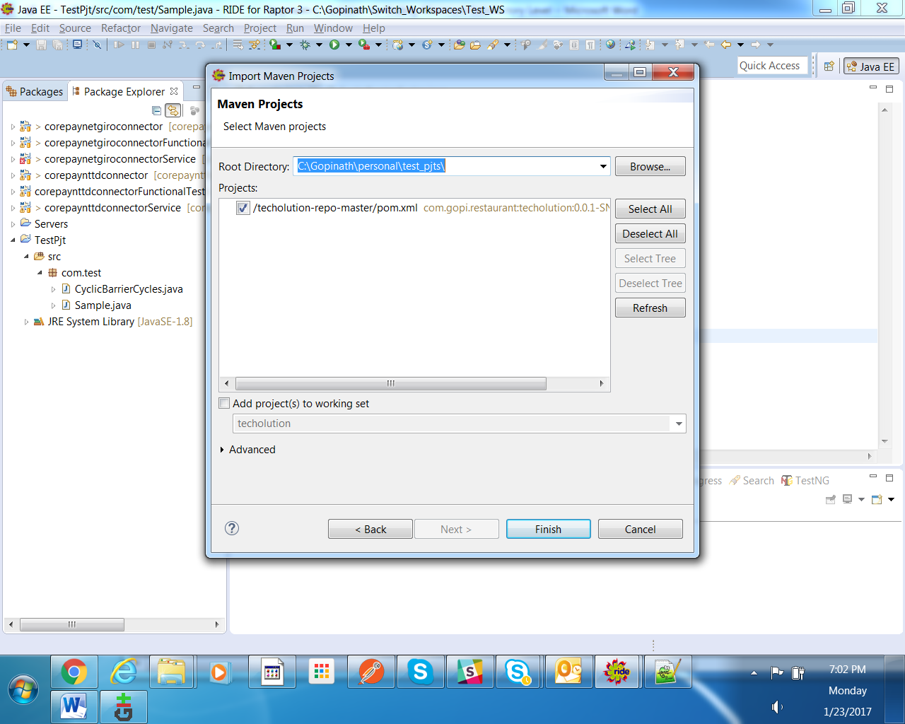

Before running , please make sure you have installed maven and update your project

and run “ maven clean install “ . The build will be success.

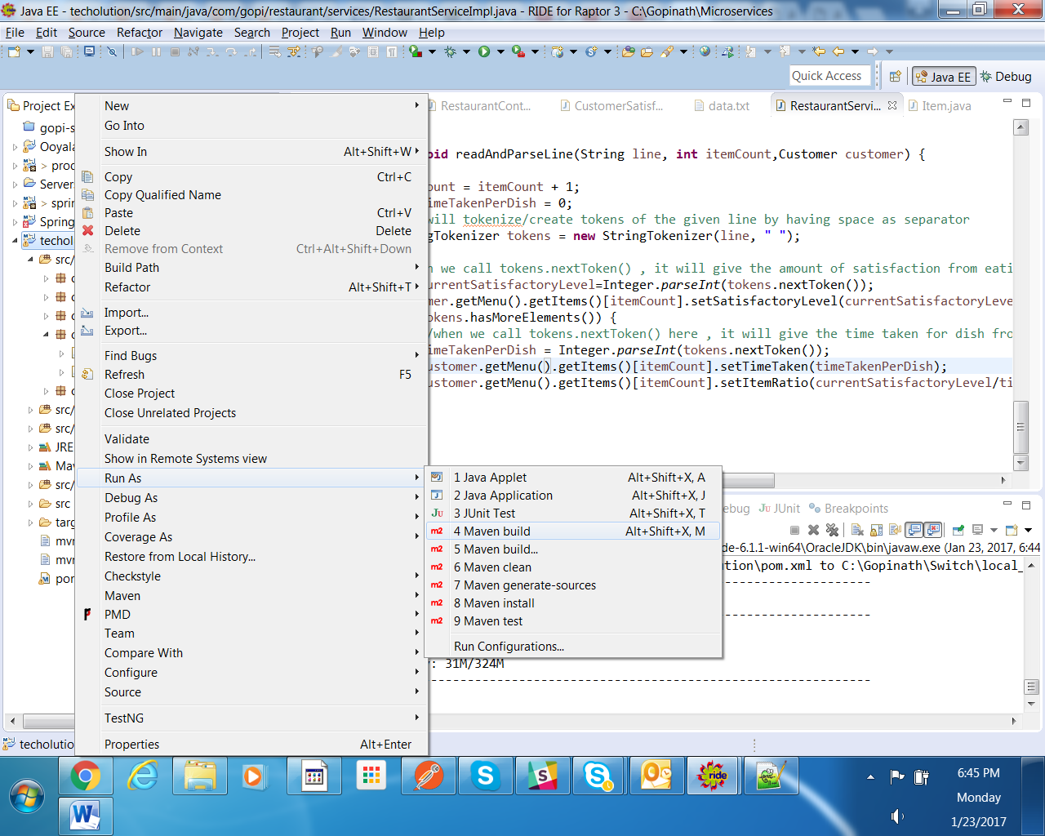

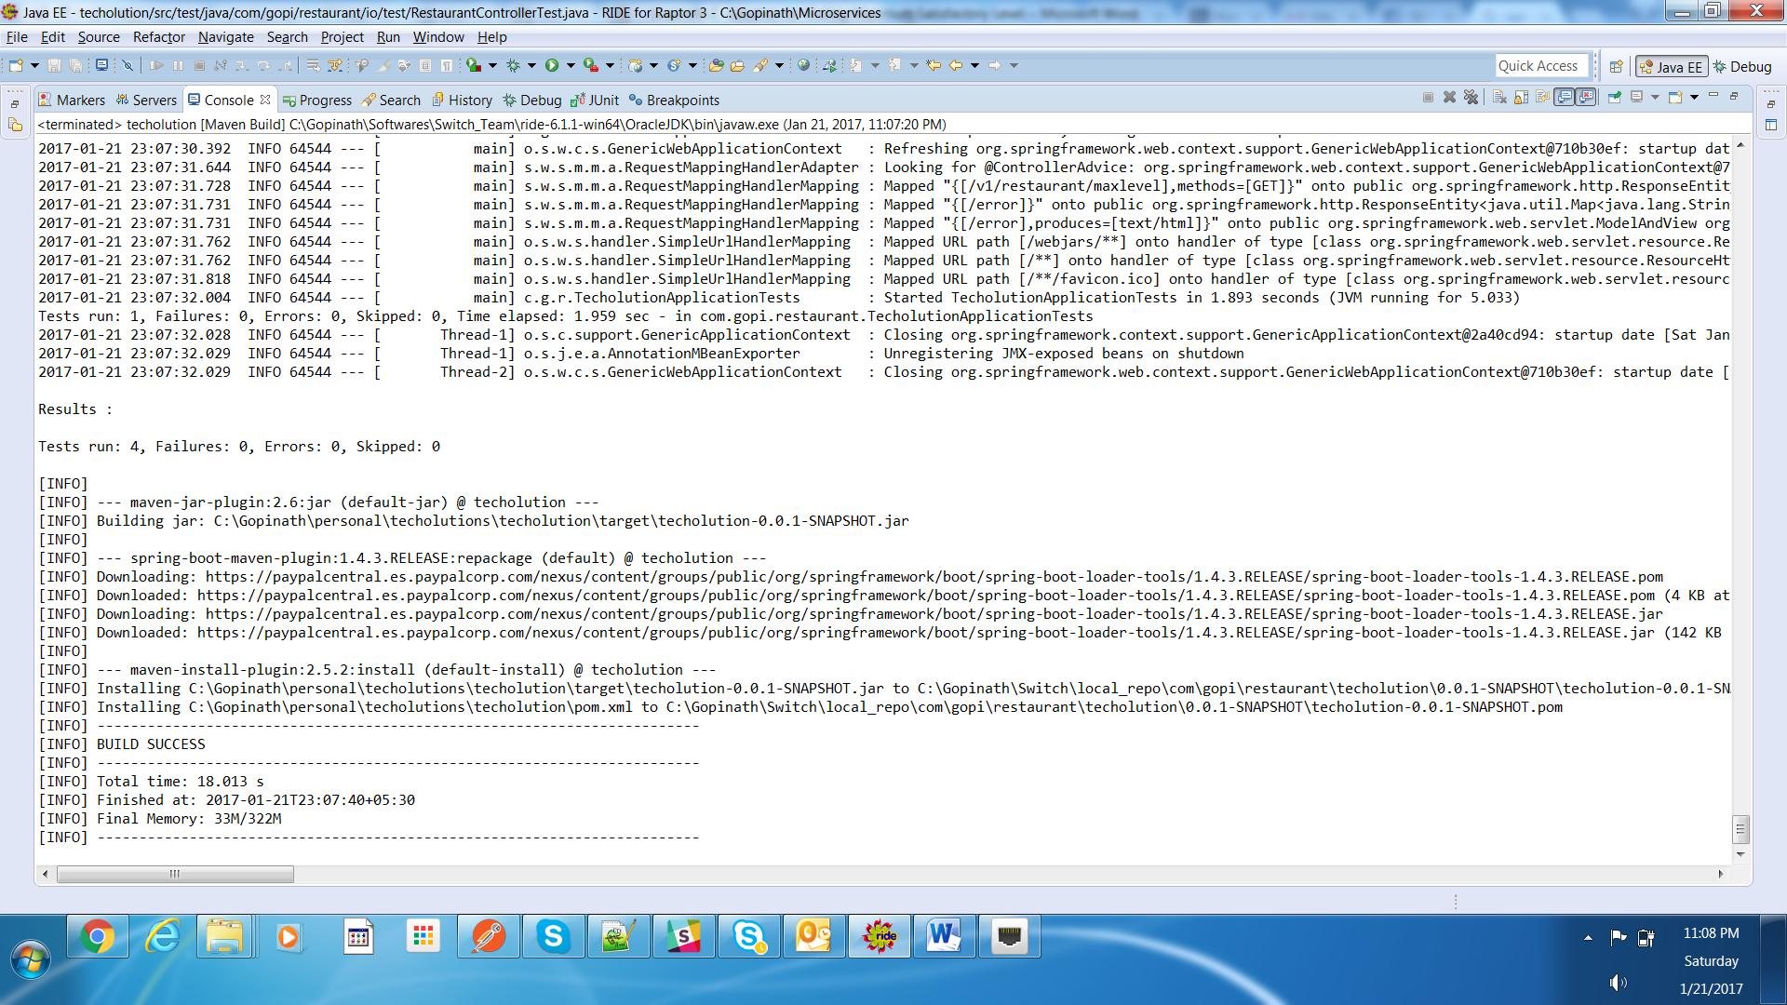

<https://github.com/gopinath-chockalingam/techolution-repo>

Approach : Red Green Refactor

I had created public methods in Controller class and later I converted those as private after the test case turned to green Ex.) private void readFileAndSetTotalItemsAndTime(String filePath) throws IOException

I have used SpringBoot and have created Microservice using a REST Service which will give a JSON response.

**Steps To Execute the Program :**

In ***RestaurantController.java,*** provide the below wrong file

private static final String INPUT_FILE_PATH="src/test/resources/**input.txt**";

**Note** : original file name is **data.txt**

The main class for this Springboot Application is **TecholutionApplication.java** which you need to run as Java Application. Refer below screenshot

**Screenshot : 1**

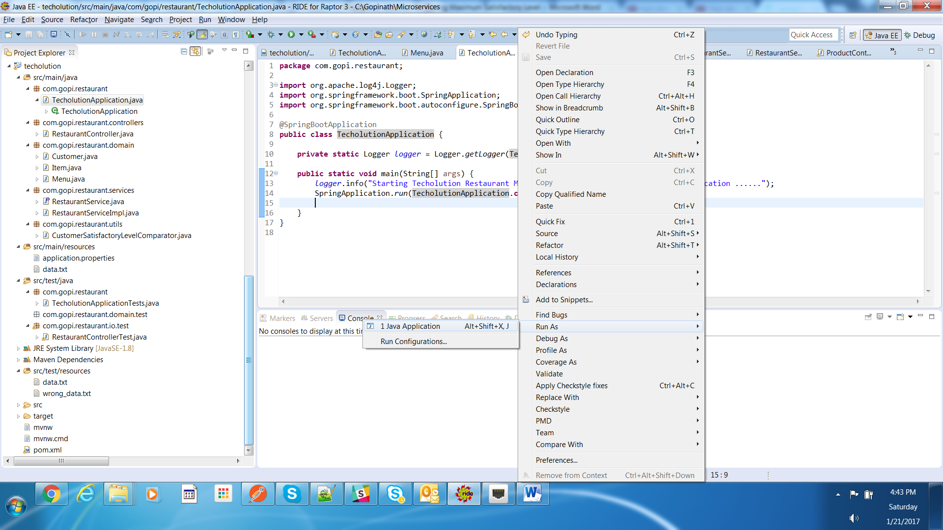

Springboot application will be up and running . Refer below the last line in screenshot ‘2017-01-21 16:44:15.214 INFO 2996 --- [ main] c.g.restaurant.TecholutionApplication : Started TecholutionApplication in 3.524 seconds (JVM running for 3.859)’

**Screenshot: 2**

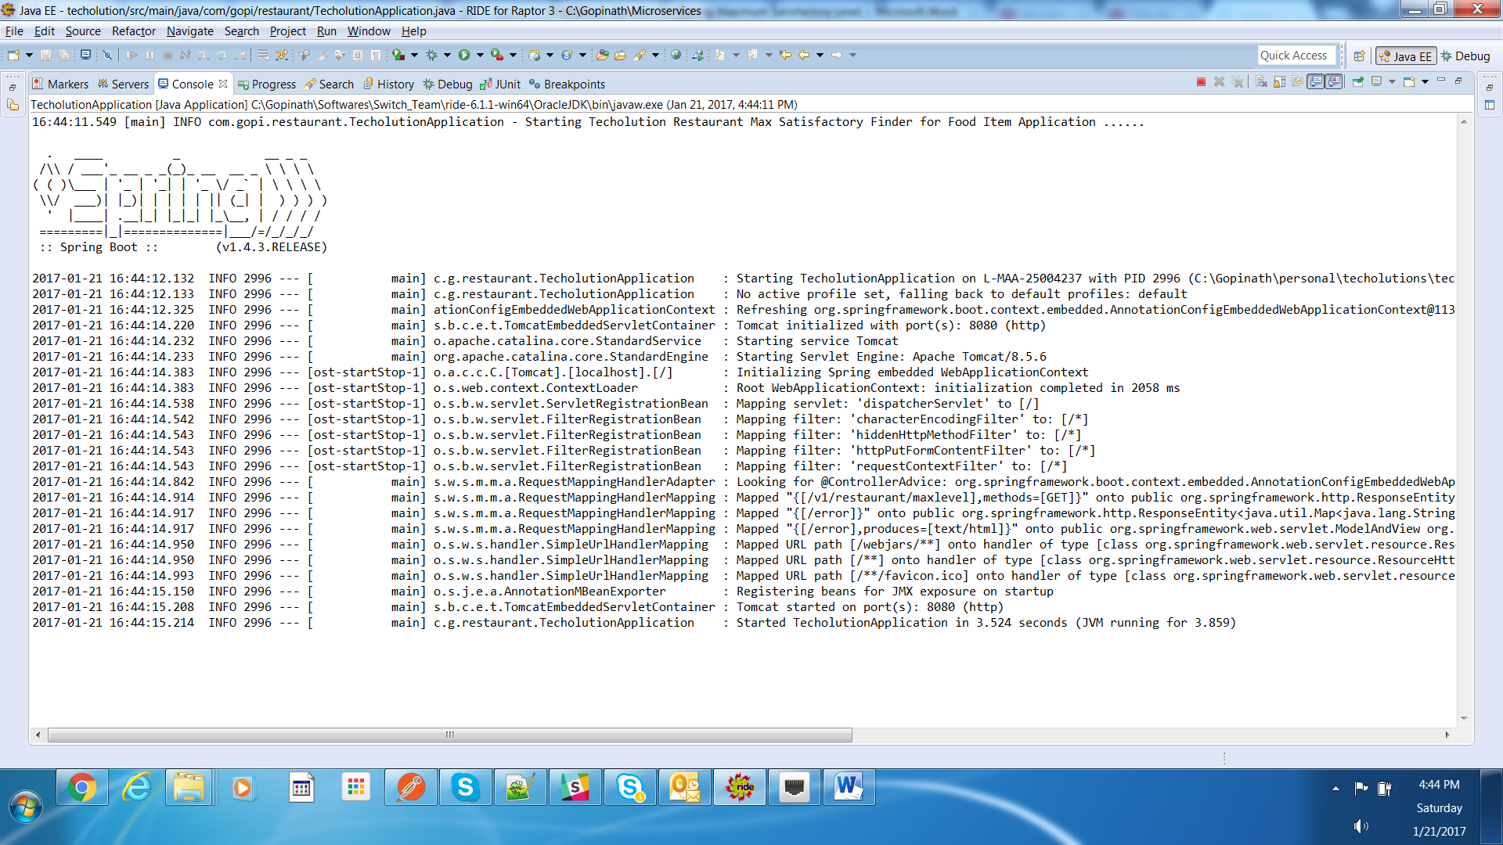

The rest url to get MaximumSatisfactory level is <http://localhost:8080/v1/restaurant/maxlevel>

After starting the application , hit the above url in any of the Rest client tools like , POSTMAN , Chrome RestClient , Browser…etc

Make sure you have added the header as

Content-Type application/json

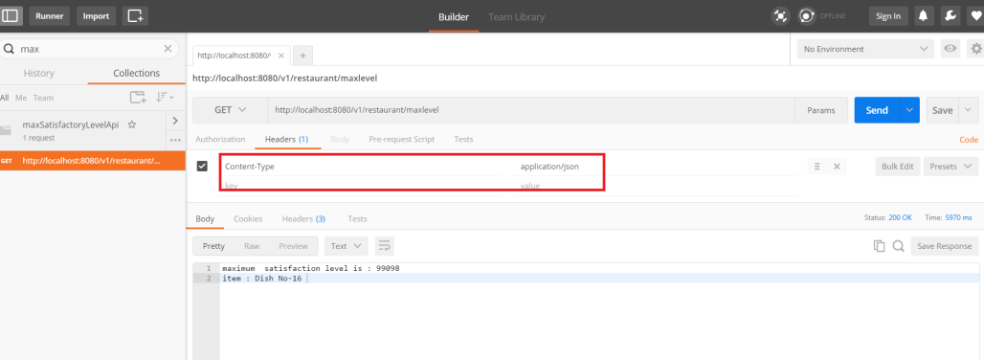

FYI, I have used Postman to test my REST services

If you hit the above url , you will get response like below

“Input file not found in the file sytem to process “

Because we have used wrong input file called input.txt instead of data.txt

Please refer below screenshot 3 below

**Screenshot: 3**

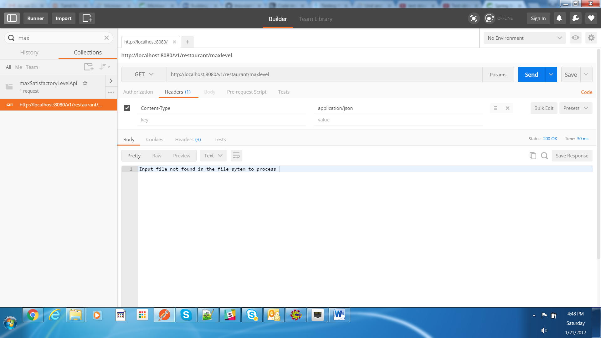

Stop / Terminate the springboot application.

Revert back the file name in as RestaurantController.java as

private static final String INPUT_FILE_PATH="src/test/resources/**data.txt**";

start the application – Refer **Screenshot 1**

**Hit url :** <http://localhost:8080/v1/restaurant/maxlevel>

**You will find the as in the given format below**

maximum satisfaction level is : 2464718

**=====================================================================================**

**Assumptions** : As per the discussion , No database OR DAO layer is required for this Microservice. Customer will eat all items as per the order present in the data.txt file.

I have considered the entire functionality as a single Microservice. The rest service is secured using any of the security mechanism like OAuth , Spring security , OR Client certificate handshake …etc

Assuming it has features like  security / metrics / caching / healthcheck OR heartbeat Service and no need of these features implementation.

=====================================================================================

I have not used any database / DAO layer and have created simple Rest service to return the response even though I followed Microservices Architecture for this problem.

About Solution:

I have used the knapsack fractional approach to derive the solution.

I have read the file and have read the first line inputs (Total time given) 10000 , [**Number of items** on menu] 100 and will set this parameters and will create an Item[**100**] Array with the given size above.

I have prepared each item (Item.java) to identify the dish name and satisfactorylevel and ratio of Item (Satisfactorylevel/timeTakenByDish)

Composite: Also, I have used Customer Object which will have customerName (Gordon Ramsey) in our assignment case and will have his Menu to see items to eat. If there is no Customer, then there is no use of having Menu in Restaurant

Composite: Menu class will hold items[] and have used composite instead of aggregation as the items will not exist if the Menu destroys.

I have populated the items with name and have used index from 1 to 100

Ex) **Item** will have dish name and satisfactorylevel and the corresponding time taken for that dish

Dish Name SatisfactoryLevel TimeTaken itemRatio

Dish No-1 16808 250 (16808/250) =67

. . . .

. . . .

Dish No –N XX YY ZZ

I have set the above properties of Item.java while reading the data.txt file and have finally sorted using CustomerSatisfactoryRatioComparator.java in descending order (based on itemRatio = SatisfactoryLevel / timeTakenByDish )

**Non-overflow condition (Taking whole Item)** Ex, timeSofarBeforeEatingDish > theTotalTimeGiven (10000)

While reading this , I am maintaining a variable(timeSofarBeforeEatingDish)and incrementing the same by summing up the timetaken per dish and will verify the timeSofarBeforeEatingDish > theTotalTimeGiven

If the time is lesser then the customer will take/eat the whole item/dish and will

Sum up totalSatisfactoryLevel+= totalSatisfactoryLevel+currentItem’s satisfactoryLevel

read next item and so on.

**Overflow case :** Ex) timeSofarBeforeEatingDish (10277) > theTotalTimeGiven (10000)

If thetimeSofarBeforeEatingDish is exceeds the theTotalTimeGiven then I have used the fractional knapsack technique.

**If(10277 > 10000)** {

//I will find out the remaining time

Remaining time (277) = 10277 – 10000

// using fractional now to calculate the optimistic //solution/satisfactorylevel

totalSatisfactoryLevel+= currentSatisfactoryLevel of currentItem * (remaining time / timeTakenByCurrentItem)

}

**Refer** , private String eatAndCalculateMaxSatisfactoryLevel (Item[] items,Customer customer){

method in RestaurantServiceImpl.java class

If you run the program, you can see the below console output in your eclipse console

**Eclipse console output** :

Total time in mins is.. 10000

Total no of items .. 100

Gordon Ramsey ate/finished Dish No-75 for about 7 mins and got satisfactory level of 37336 having ratio as 5333.0

Gordon Ramsey ate/finished Dish No-62 for about 9 mins and got satisfactory level of 41595 having ratio as 4621.0

Gordon Ramsey ate/finished Dish No-99 for about 12 mins and got satisfactory level of 46043 having ratio as 3836.0

Gordon Ramsey ate/finished Dish No-37 for about 14 mins and got satisfactory level of 28636 having ratio as 2045.0

Gordon Ramsey ate/finished Dish No-7 for about 43 mins and got satisfactory level of 84493 having ratio as 1964.0

Gordon Ramsey ate/finished Dish No-32 for about 25 mins and got satisfactory level of 28550 having ratio as 1142.0

Gordon Ramsey ate/finished Dish No-76 for about 99 mins and got satisfactory level of 97973 having ratio as 989.0

Gordon Ramsey ate/finished Dish No-46 for about 124 mins and got satisfactory level of 82189 having ratio as 662.0

Gordon Ramsey ate/finished Dish No-19 for about 150 mins and got satisfactory level of 80980 having ratio as 539.0

Gordon Ramsey ate/finished Dish No-29 for about 197 mins and got satisfactory level of 88125 having ratio as 447.0

Gordon Ramsey ate/finished Dish No-91 for about 218 mins and got satisfactory level of 97386 having ratio as 446.0

Gordon Ramsey ate/finished Dish No-6 for about 166 mins and got satisfactory level of 64441 having ratio as 388.0

Gordon Ramsey ate/finished Dish No-80 for about 127 mins and got satisfactory level of 48906 having ratio as 385.0

Gordon Ramsey ate/finished Dish No-50 for about 145 mins and got satisfactory level of 54439 having ratio as 375.0

Gordon Ramsey ate/finished Dish No-78 for about 224 mins and got satisfactory level of 83455 having ratio as 372.0

Gordon Ramsey ate/finished Dish No-83 for about 95 mins and got satisfactory level of 35239 having ratio as 370.0

Gordon Ramsey ate/finished Dish No-100 for about 153 mins and got satisfactory level of 54680 having ratio as 357.0

Gordon Ramsey ate/finished Dish No-57 for about 176 mins and got satisfactory level of 59746 having ratio as 339.0

Gordon Ramsey ate/finished Dish No-14 for about 279 mins and got satisfactory level of 93100 having ratio as 333.0

Gordon Ramsey ate/finished Dish No-24 for about 92 mins and got satisfactory level of 25229 having ratio as 274.0

Gordon Ramsey ate/finished Dish No-66 for about 366 mins and got satisfactory level of 97943 having ratio as 267.0

Gordon Ramsey ate/finished Dish No-11 for about 170 mins and got satisfactory level of 44304 having ratio as 260.0

Gordon Ramsey ate/finished Dish No-93 for about 386 mins and got satisfactory level of 99248 having ratio as 257.0

Gordon Ramsey ate/finished Dish No-72 for about 58 mins and got satisfactory level of 14739 having ratio as 254.0

Gordon Ramsey ate/finished Dish No-41 for about 95 mins and got satisfactory level of 24116 having ratio as 253.0

Gordon Ramsey ate/finished Dish No-59 for about 400 mins and got satisfactory level of 98143 having ratio as 245.0

Gordon Ramsey ate/finished Dish No-43 for about 196 mins and got satisfactory level of 46518 having ratio as 237.0

Gordon Ramsey ate/finished Dish No-89 for about 160 mins and got satisfactory level of 36551 having ratio as 228.0

Gordon Ramsey ate/finished Dish No-26 for about 154 mins and got satisfactory level of 35002 having ratio as 227.0

Gordon Ramsey ate/finished Dish No-58 for about 299 mins and got satisfactory level of 53636 having ratio as 179.0

Gordon Ramsey ate/finished Dish No-92 for about 540 mins and got satisfactory level of 95273 having ratio as 176.0

Gordon Ramsey ate/finished Dish No-15 for about 336 mins and got satisfactory level of 51817 having ratio as 154.0

Gordon Ramsey ate/finished Dish No-77 for about 320 mins and got satisfactory level of 49096 having ratio as 153.0

Gordon Ramsey ate/finished Dish No-42 for about 502 mins and got satisfactory level of 75630 having ratio as 150.0

Gordon Ramsey ate/finished Dish No-54 for about 398 mins and got satisfactory level of 53178 having ratio as 133.0

Gordon Ramsey ate/finished Dish No-10 for about 613 mins and got satisfactory level of 78841 having ratio as 128.0

Gordon Ramsey ate/finished Dish No-69 for about 713 mins and got satisfactory level of 85696 having ratio as 120.0

Gordon Ramsey ate/finished Dish No-16 for about 827 mins and got satisfactory level of 99098 having ratio as 119.0

Gordon Ramsey ate/finished Dish No-98 for about 535 mins and got satisfactory level of 61626 having ratio as 115.0

Gordon Ramsey ate/finished Dish No-33 for about 854 mins and got satisfactory level of 97802 having ratio as 114.0

**Screenshot 4:** Response format

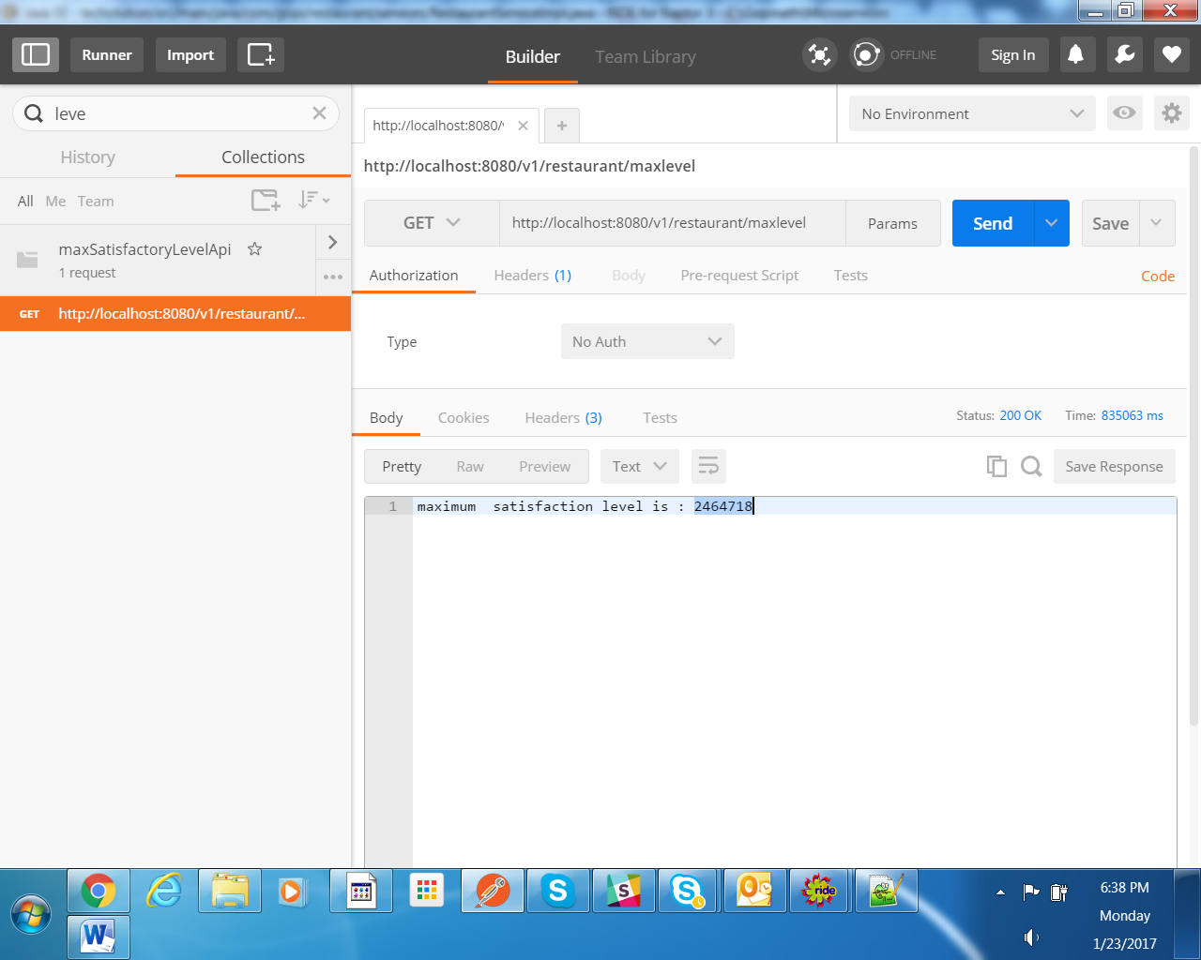

**Final Response** :maximum satisfaction level is **: 2464718**